##### <Manager>Edit Task

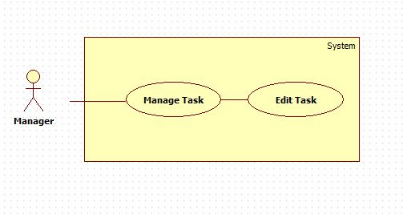

Figure 5: <Manager>Edit Task

|  |  |  |  |
| --- | --- | --- | --- |
| **USE CASE – OTM001** | | | |
| **Use Case No.** | OTM001 | **Use Case Version** | 1.0 |
| **Use Case Name** | Edit Task | | |
| **Author** | Nguyễn Cự Đạt | | |
| **Date** | 03-06-2015 | **Priority** | Normal |
| **Actor:**   * Manager   **Summary:**   * This use case allows manager to edit a task in project which manager manages.   **Goal:**   * Task’s detail is changed.   **Triggers:**  Manager chooses “Edit” button on Task Detail page.  **Preconditions**:   * Log into the system with the role Manager. * The task must be in the project which manager manages.   **Post Conditions:**   * **Success**: Task’s detail is changed. * **Fail**: System shows error message.   **Main Success Scenario:**   |  |  |  | | --- | --- | --- | | Step | Actor Action | System Response | | 1 | Manager chooses “Edit” on Task Detail Page. | System shows new popup contains:   * “Project Name”: link. * “Created By”: label. * “Assignee”: drop down list. * “Approve By”: label. * “Status”: label. * “Create Date”: label. * “Deadline”: date time picker. * “Close Date”: label. * “Priority”: check box. * “Level”: drop down list. * “Description”: text area, max length 200. * “Save Changes”: button. * “Close”: button | | 2 | Manager inputs data |  | | 3 | Manager clicks “Save Changes” button | System closes current popup and shows Task Detail Page with the content has changed.  [Alternative 1, 2]  [Exception 1] exception còn thiếu 1 đống validate |   **Alternative Scenario:**   |  |  |  | | --- | --- | --- | | No | Actor Action | System Response | | 1 | Manager clicks “Close” button. | Edit Task Popup will be closed. | | 2 | Manager clicks in a place out of range of popup. | Edit Task Popup will be closed. |   **Exceptions:**   |  |  |  | | --- | --- | --- | | No | Actor Action | System Response | | 1 | Manager set Deadline before Created Date. | System shows message “Deadline must be set after Created Date.” |   **Relationships**: N/A  **Business Rules:**   * Must have role manager, director in the project to edit this project’s task. * If task status is “New”, a “Remove” button will be shown in edit task popup. * If task status is “Pending”(waiting for staff accept the task), “Assignee” is a label now. * If Manager don’t select the values of “Level”, the initial values will be the first value of the drop down list. * If Manager don’t check on “Priority”, the initial values will be normal priority. * If task status is “Closed”, “Summary” input field(text area max length 200) and “Mark” input field(text box, type number, max value 5) will be shown. * If task status is “Closed” all fields become not editable * Director manages all projects so can edit tasks in any projects. Câu note này cần thống nhất chung | | | |

Table 1: <Manager>Edit Task

##### <Manager>Assign Task

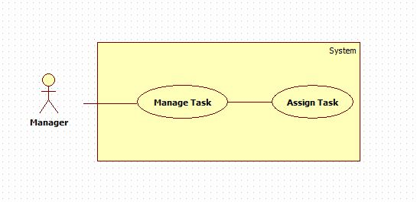

Figure 5: <Manager>Assign **Task**

|  |  |  |  |
| --- | --- | --- | --- |
| **USE CASE – OTM002** | | | |
| **Use Case No.** | OTM002 | **Use Case Version** | 1.0 |
| **Use Case Name** | Assign Task | | |
| **Author** | Nguyễn Cự Đạt | | |
| **Date** | 03-06-2015 | **Priority** | High |
| **Actor:**   * Manager   **Summary:**   * This use case allows Manager assigns task to Staff.   **Goal:**   * Assign staff for task is successful and no error was caught.   **Triggers:**  Manager chooses “Edit” on Task Detail Page, then input staff and choose ”Save Changes”.  Manager chooses “Create Task” from Dash Board Manager page, then input staff and choose “Create” button.  **Preconditions**:   * Log into the system with the role Manager. * The task is not assigned for any other staff. * The task must be in the project which manager manages.   **Post Conditions:**   * **Success**: Staff was notified. * **Fail**: System shows error message.   **Main Success Scenario:**   |  |  |  | | --- | --- | --- | | Step | Actor Action | System Response | | 1 | Manager chooses “Task Details” on Task List Page, then choose “Edit” button.  [Alternative 1] | System shows new popup contains:   * “Project Name”: link. * “Created By”: label. * “Assignee”: drop down list. * “Approve By”: label. * “Status”: label. * “Create Date”: label. * “Deadline”: date time picker. * “Close Date”: label. * “Priority”: check box. * “Level”: drop down list. * “Description”: text area, max length 200. * “Save Changes”: button. * “Close”: button | | 2 | Manager inputs data in “assignee” part. |  | | 3 | Manager clicks “Save Changes” button. | System closes current popup and shows Task Detail Page with the content has changed.  [Alternative 1, 2]  [Exception 1] |   **Alternative Scenario:**   |  |  |  | | --- | --- | --- | | No | Actor Action | System Response | | 1 | Manager clicks “Close” button. | Edit Task Popup will be closed. | | 2 | Manager clicks in a place out of range of popup. | Edit Task Popup will be closed. |   **Exceptions:**   |  |  |  | | --- | --- | --- | | No | Actor Action | System Response | | 1 | Created Date higher than Deadline. | System shows message “Deadline must be higher than Created Date.” | | 2 |  |  | | 3 |  |  |   **Relationships**: N/A  **Business Rules:**   * Must have role manager in the project to edit this project’s task and assign staff. * If Manager don’t select the values of “Level”, the initial values will be the first value of the drop down list. * If Manager don’t check on “Priority”, the initial values will be normal priority. * If task status is “Close”, “Summary” input field (text area max length 200) and “Mark” input field (text box, type number, max value 5) will be shown. * Director manages all projects so can edit tasks in any projects. * A notify will be sent to staff when “Save Changes” button is clicked. * Task status when assigning success will be changed to “Pending”. | | | |

Table 2: <Manager>Assign Task

##### <Manager>Task Review

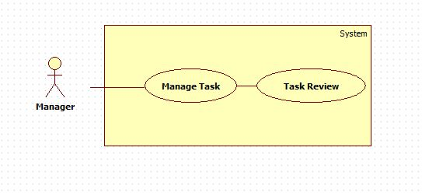

Figure 5: <Manager>Task **Review**

|  |  |  |  |
| --- | --- | --- | --- |
| **USE CASE – OTM003** | | | |
| **Use Case No.** | OTM003 | **Use Case Version** | 1.0 |
| **Use Case Name** | Task Review | | |
| **Author** | Nguyễn Cự Đạt | | |
| **Date** | 03-06-2015 | **Priority** | Normal |
| **Actor:**   * Manager   **Summary:**   * This use case is allows Manager review the task when task is done.   **Goal:**   * Task status become “Redo” or “Closed”.   **Triggers:**  Manager clicks on the Task on Task List page.  **Preconditions**:   * Log into the system with Manager role. * The task must be in the project which manager manages. * Task status must be “Done”.   **Post Conditions:**   * **Success**: Task status become “Redo” or “Closed” and the system notify to a staff. * **Fail**: System shows error message.   **Main Success Scenario:**   |  |  |  | | --- | --- | --- | | Step | Actor Action | System Response | | 1 | Manager clicks on the Task on Task List page. | System shows new page(Task Detail page) contains:   * “Project Name”: link. * “Created By”: label. * “Assignee”: label. * “Approve By”: label. * “Status”: label. * “Create Date”: label. * “Deadline”: label. * “Close Date”: label. * “Priority”: label. * “Level”: label . * “Description”: label. * “Approve”: button. * “Reject”: button. | | 2 | Manager clicks on “Approve” button. | System shows new popup contains:   * “Summary”: text area, max length 200, required. * “Mark”: text box, max value 5, type number required. * “Done”: button. * “Close”: button. | | 3 | Manager clicks “Done” button | System closes current popup and shows Task Detail Page with the summary’s contain was updated.  [Alternative 1, 2, 3]  [Exception 1, 2, 3] |   **Alternative Scenario:**   |  |  |  | | --- | --- | --- | | No | Actor Action | System Response | | 1 | Manager clicks “Reject” button. | Task status will be changed to “Redo” and a notify will be sent to this task’s assignee. | | 2 | Manager clicks “Close” button. | “Summary” popup will be closed. | | 3 | Manager clicks in a place out of range of popup. | Edit Task Popup will be closed. |   **Exceptions:**   |  |  |  | | --- | --- | --- | | No | Actor Action | System Response | | 1 | Manager left some fields blank. | System shows message “Please input all required field.” | | 2 |  |  | | 3 |  |  |   **Relationships**: N/A  **Business Rules:**   * Must have role manager or Director in the project to Approve or Reject this project’s task. * Director manages all projects so can Reject or Approve tasks in any projects. * A notify will be sent to staff when “Approve” or “Reject” button is clicked. * Task status when “Approve” success will be changed to “Closed” and when “Reject” button was clicked it will be changed to “Redo”. | | | |

Table 3: <Manager>Task Review